
Requirements Specification & Design Document

Prepared By: Group Clovers
Semon Chakradhar (E2300152)
Nikhil Rana (E2400001)
Aaditya Kumar Jaiswal (E2300549)

B. Design Specification Document (Group Work)

1. Architectural Design — Deployment View
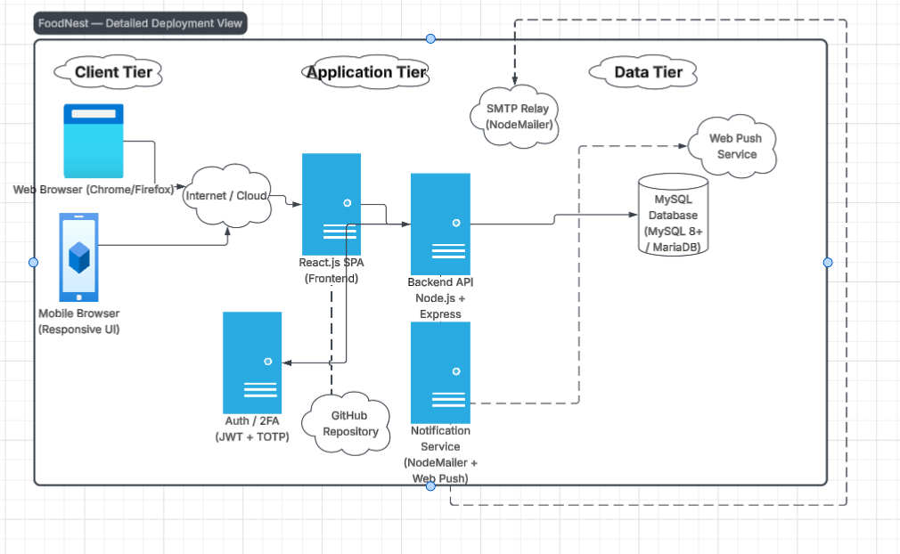
Figure 1: Deployment Diagram of FoodNest

2. Entity Relationship Diagram (Conceptual)
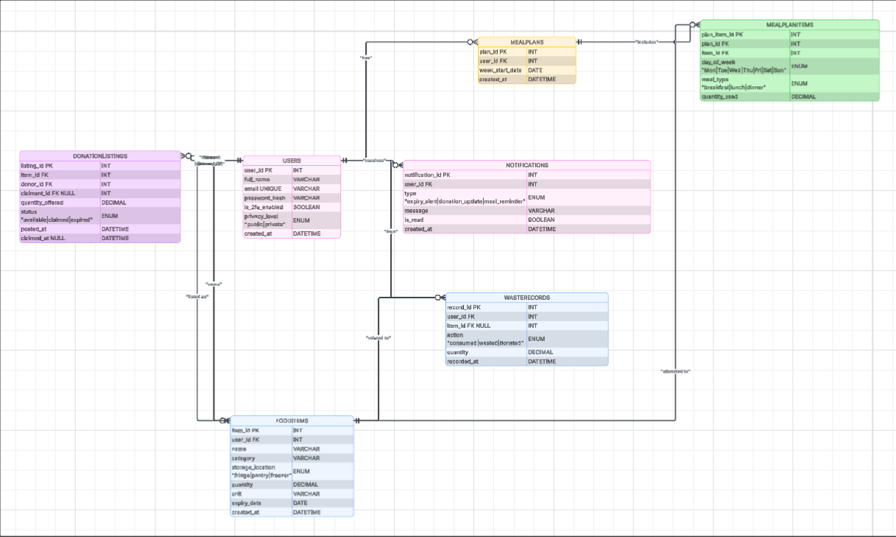
Figure 2: ERD Diagram of Food Nest

3. Site Map (Hierarchy)

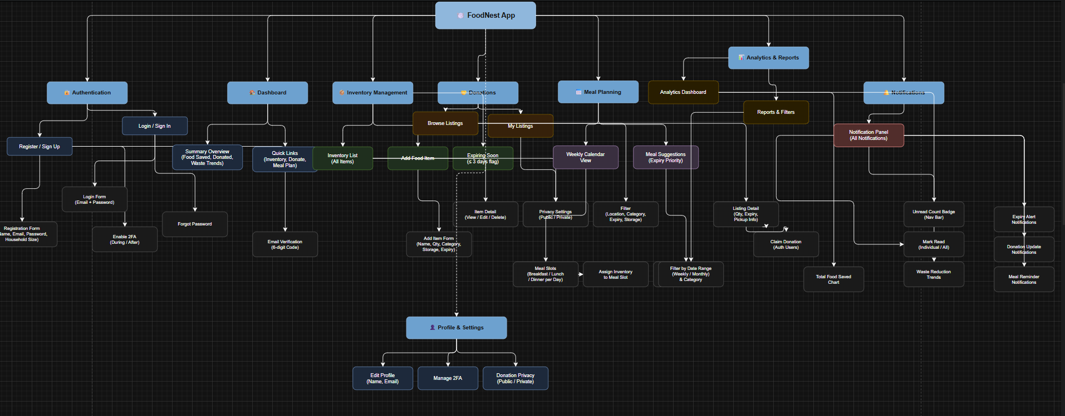
Figure 3: SiteMap of FoodNest

4. Wireframes (Low-Fidelity UX)
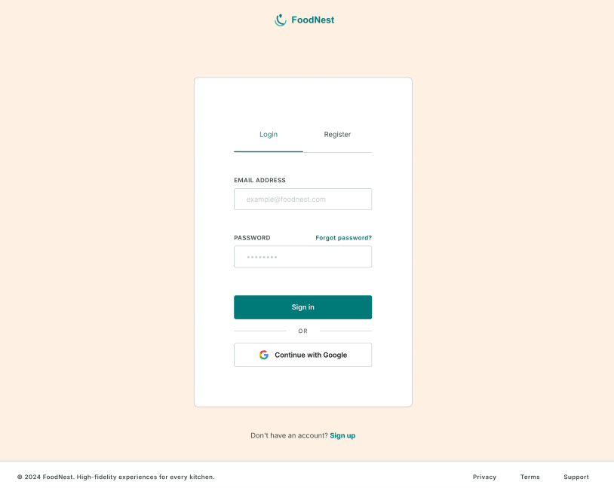
Figure 4: Login page Design

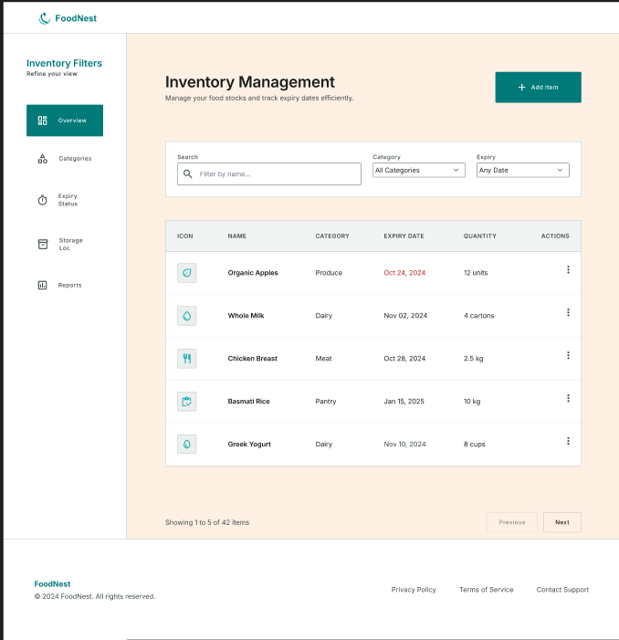
Figure 5: Inventory Management Design

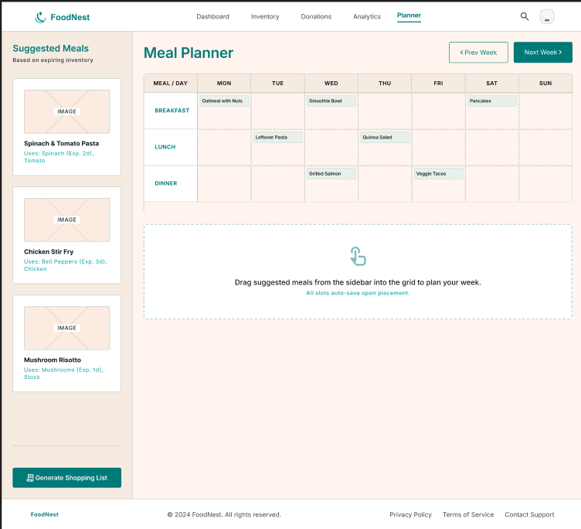
Figure 6: Meal Planning

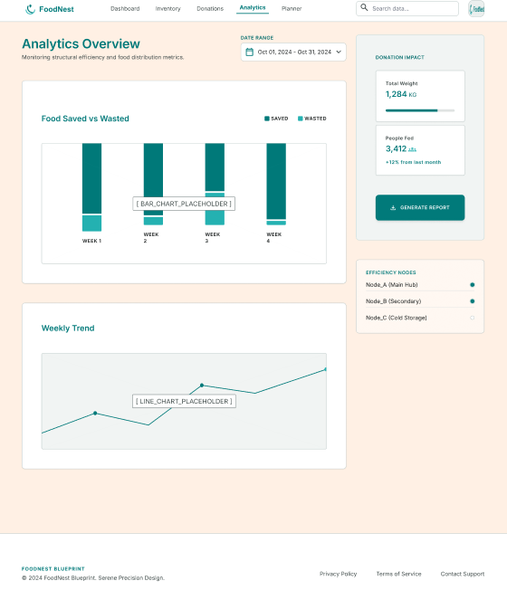
Figure 7: Analytics Overview Design

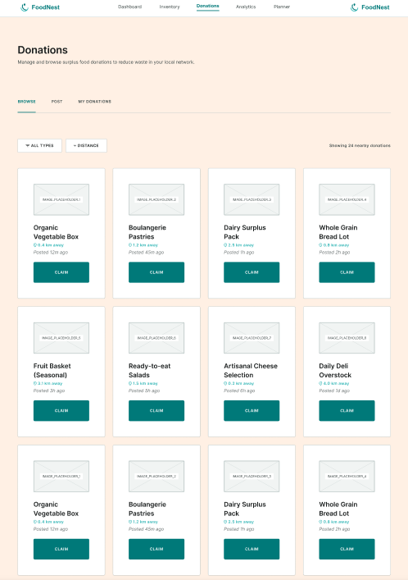
Figure 8: Donation Listing Design

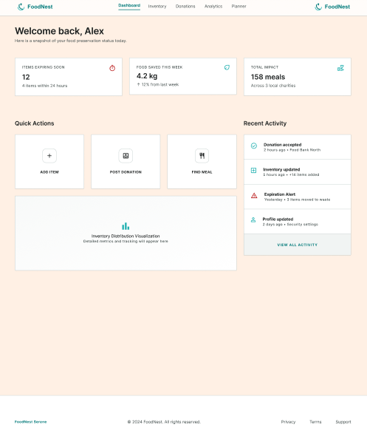
Figure 9: Dashboard Design

C. Database Design — Data Dictionary

Table: Users
Field | Type | Constraints | Description
user_id | INT | PK, AUTO_INCREMENT | Unique user identifier
full_name | VARCHAR(100) | NOT NULL | User's display name
email | VARCHAR(100) | UNIQUE, NOT NULL | Login email
password_hash | VARCHAR(255) | NOT NULL | bcrypt hashed password
is_2fa_enabled | BOOLEAN | DEFAULT FALSE | 2FA status
privacy_level | ENUM('public','private') | DEFAULT 'private' | Profile visibility on donation listings
created_at | DATETIME | NOT NULL | Account creation date

Table: FoodItems
Field | Type | Constraints | Description
item_id | INT | PK, AUTO_INCREMENT | Unique item identifier
user_id | INT | FK → Users.user_id | Owner of the item
name | VARCHAR(100) | NOT NULL | Item name
category | VARCHAR(50) | NOT NULL | e.g. dairy, produce, grain
storage_location | ENUM('fridge','pantry','freezer') | NOT NULL | Where item is stored
quantity | DECIMAL(6,2) | NOT NULL | Quantity on hand
unit | VARCHAR(20) | NOT NULL | e.g. pcs, kg, litre
expiry_date | DATE | NOT NULL | Expiry date
created_at | DATETIME | NOT NULL | Date item was logged

Table: DonationListings
Field | Type | Constraints | Description
listing_id | INT | PK, AUTO_INCREMENT | Unique listing identifier
item_id | INT | FK → FoodItems.item_id | Food item being donated
donor_id | INT | FK → Users.user_id | User who posted the donation
claimant_id | INT | FK → Users.user_id, NULLABLE | User who claimed the donation
quantity_offered | DECIMAL(6,2) | NOT NULL | Quantity offered for donation
status | ENUM('available','claimed','expired') | DEFAULT 'available' | Listing status
posted_at | DATETIME | NOT NULL | When the listing was posted
claimed_at | DATETIME | NULLABLE | When the listing was claimed

Table: MealPlans
Field | Type | Constraints | Description
plan_id | INT | PK, AUTO_INCREMENT | Unique meal plan identifier
user_id | INT | FK → Users.user_id | Owner of the meal plan
week_start_date | DATE | NOT NULL | Start date of the planned week
created_at | DATETIME | NOT NULL | When the plan was created

Table: MealPlanItems
Field | Type | Constraints | Description
plan_item_id | INT | PK, AUTO_INCREMENT | Unique meal-plan-item identifier
plan_id | INT | FK → MealPlans.plan_id | Parent meal plan
item_id | INT | FK → FoodItems.item_id | Inventory item used in the meal
day_of_week | ENUM('Mon'...'Sun') | NOT NULL | Day the meal is planned for
meal_type | ENUM('breakfast','lunch','dinner') | NOT NULL | Meal slot
quantity_used | DECIMAL(6,2) | NOT NULL | Quantity of item allocated to the meal

Table: Notifications
Field | Type | Constraints | Description
notification_id | INT | PK, AUTO_INCREMENT | Unique notification identifier
user_id | INT | FK → Users.user_id | Recipient
type | ENUM('expiry_alert','donation_update','meal_reminder') | NOT NULL | Notification category
message | VARCHAR(255) | NOT NULL | Notification text
is_read | BOOLEAN | DEFAULT FALSE | Read status
created_at | DATETIME | NOT NULL | When the notification was generated

Table: WasteRecords
Field | Type | Constraints | Description
record_id | INT | PK, AUTO_INCREMENT | Unique record identifier
user_id | INT | FK → Users.user_id | User the record belongs to
item_id | INT | FK → FoodItems.item_id, NULLABLE | Related item (nullable if item later deleted)
action | ENUM('consumed','wasted','donated') | NOT NULL | Outcome of the item
quantity | DECIMAL(6,2) | NOT NULL | Quantity affected
recorded_at | DATETIME | NOT NULL | When the outcome was logged

Conclusion
The requirement specification and Design Document has presented a comprehensive and structured foundation for the development of Food-Nest, a smart food waste reduction web application that is fully build in the response to the Save Plate case study provided by university/ This document has successfully fulfilled all of the requirements of Assignment 1, Task 2 by clearly defining functional and non-functional requirements of the system and modelling them properly with well structured epics, user story, acceptance criteria, MoSCow prioritization and development task for the each of the assigned use case.
The design specification shows the further strength for the foundation by providing the group with the shared architectural vision through the deployment diagram, entity relationship diagram, site map, low-fidelity wireframes and a detailed data directory. This helps to ensure that all the three team members have a clear and consistent understanding of the system before the development phase starts.

